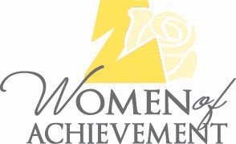
2024 Nomination Application Form

(This form must be completed by the individual making the nomination, who does not have to be a Zonta member.)
Zonta International is a global organization of executives and professionals working together to advance the status of women worldwide through service and advocacy. Membership consists of more than 30,000 members belonging to 1,200 clubs in 67 countries. The Zonta Club of Jefferson City was established in 1947. The first Yellow Rose Luncheon, honoring Women of Achievement who live or work in Jefferson City, was held on May 16, 2000. Proceeds from the event support the club’s Second Chance Scholarship program, benefitting women returning to school.
Nominator's Contact Information:
Nominator Name:
Address: City/State/Zip
Phone: E-mail:
I agree that my name may be shared as the person nominating the honoree listed below.
Signature Date
Please attach a letter (1-2 pages) briefly describing the professional and/or volunteer achievements which prompted you to nominate the woman named below. Space and time limitations restrict the number of women who can be recognized in any one year. The Awards Committee needs to know why you think she is worthy of recognition and will use the information provided by you to determine if your nominee will be honored in 2024. More detailed information will be provided by your nominee for the judges should your person be selected.
I nominate as a 2024 Zonta Woman of Achievement.
Business
Title E-Mail
Business Address Business Phone
Cell or Home Phone
Home Address
Please email this form and your nomination letter to:
jbeetem@embarqmail.com. This nomination application must be emailed no later than November 15, 2024.

